**Coursework 1**

Carissa Ying Geok Teng A0205190R

**Q1**

The just noticeable difference is the minimum change to a stimulus that can be detected at least half the time. On average, we can detect 700-900 shades of grey and about 1 million colours.

**Q2**

Sunlight comprises of lights of different wavelengths. Molecules in the earths atmosphere refract different wavelengths of lights at different angles. Blue light has a shorter wavelength and is hence scattered more by the atmosphere, making the sky blue.

During sunsets, the sun is low on the horizon. The light has to travel a longer distance through the atmosphere to reach our eyes. At this point, shorter wavelengths of light are scattered away, leaving the longer wavelengths of light, such as red.

**Q3**

Car:

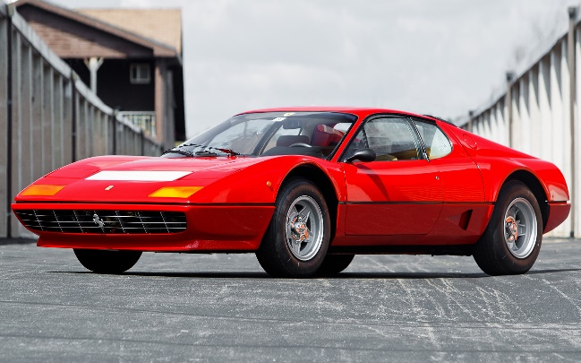 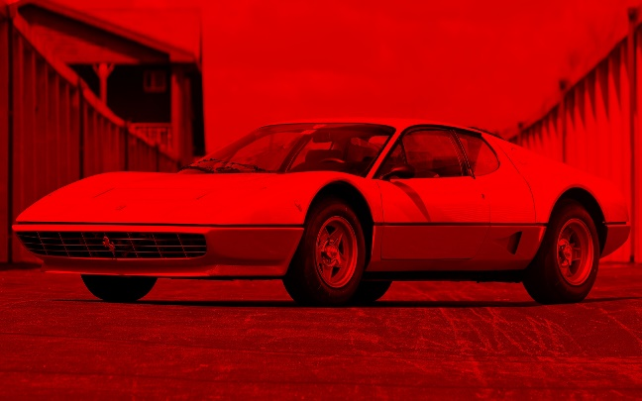

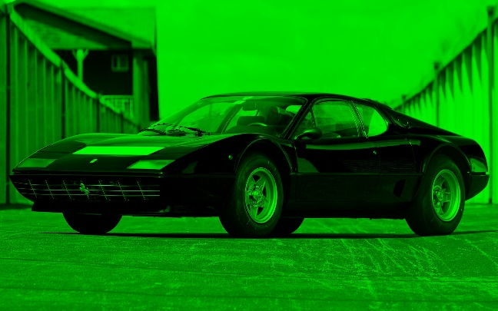 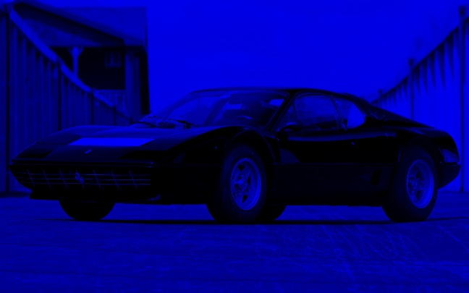

Red Channel Power: 27846.79942578125

Green Channel Power: 21715.563685329864

Blue Channel Power: 22387.477006944446

Since the car is mostly red, more of the red pixels have a higher saturation, increasing the power of the red channel

Cat:

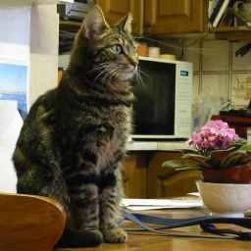 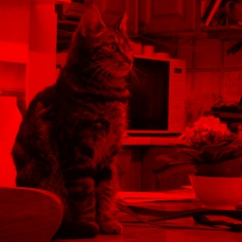

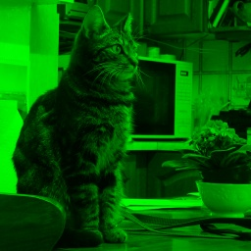 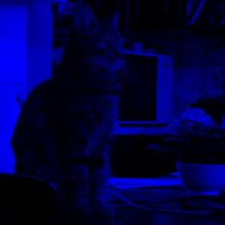

Red Channel Power: 14484.7470703125

Green Channel Power: 12635.6376953125

Blue Channel Power: 9089.672668457031

As we can see from the channels, the blue channel darker than the other 2 channels, indicating less power. This is likely because the image has more yellow tones, which are made of green and red light.

The cat image is also darker than the car. Hence, all the channels have a lower power.

**Q4**

Car:

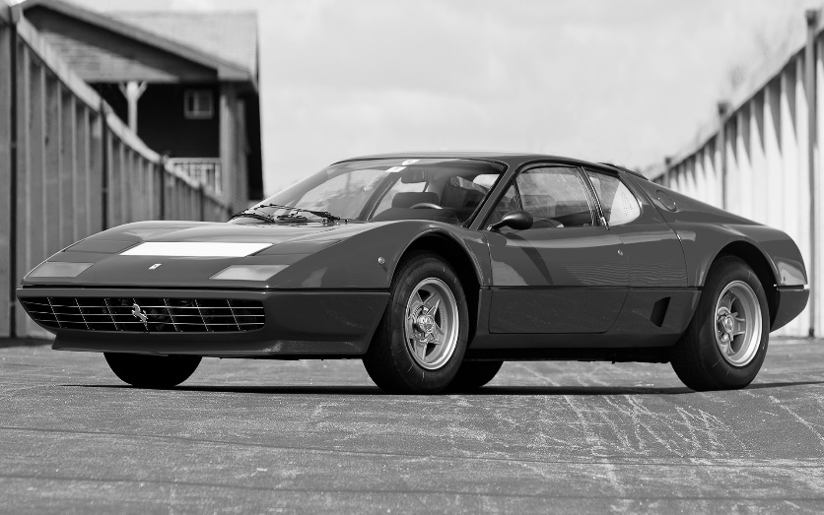

Cat:

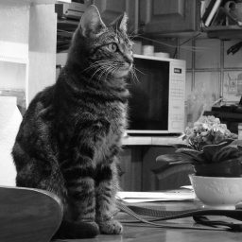

**Q5**

Car:

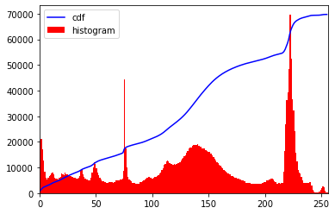

Dynamic Range: (0, 255)

Cat:

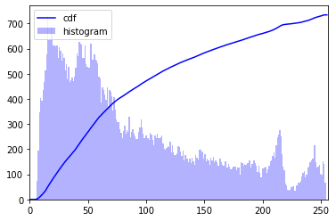

Dynamic Range: (5, 253)

**Q6**

Car (16 levels):

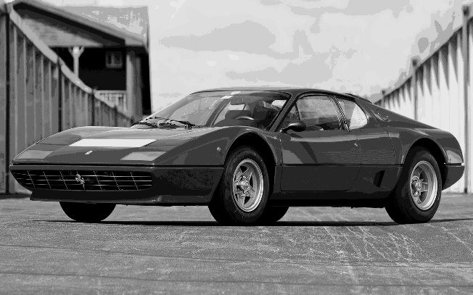 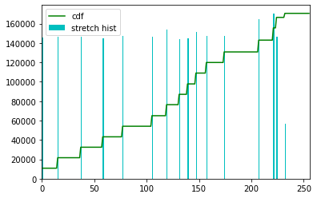

Car (4 levels):

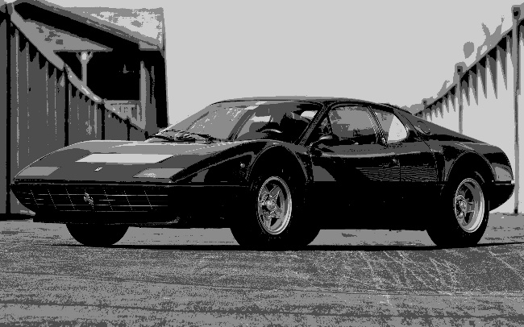 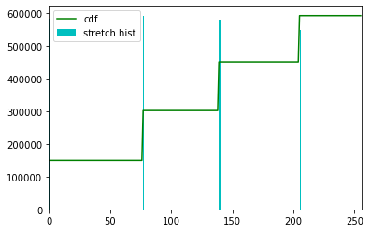

Car (2 levels):

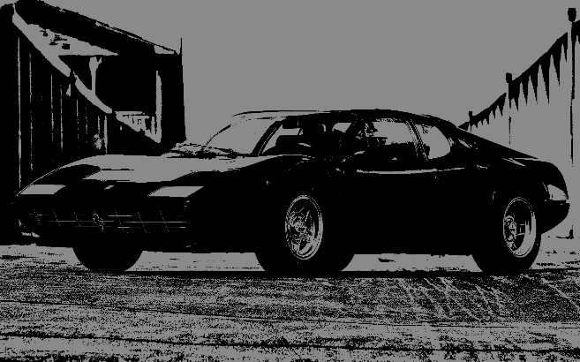 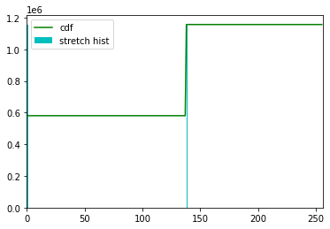

Cat (16 levels):

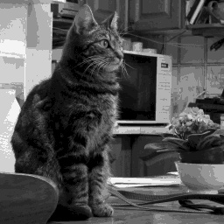 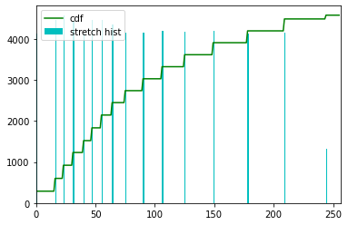

Cat (4 levels):

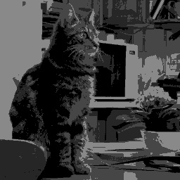 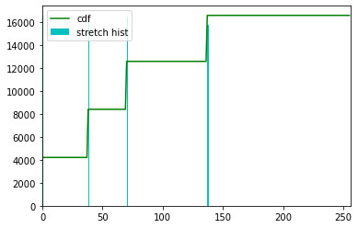

Cat (2 levels):

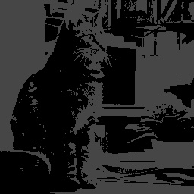 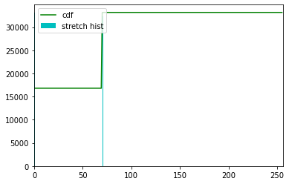

As the number of levels decreases, the contrast increases. This is because the difference between levels is more distinct.

**Q7**

Original:

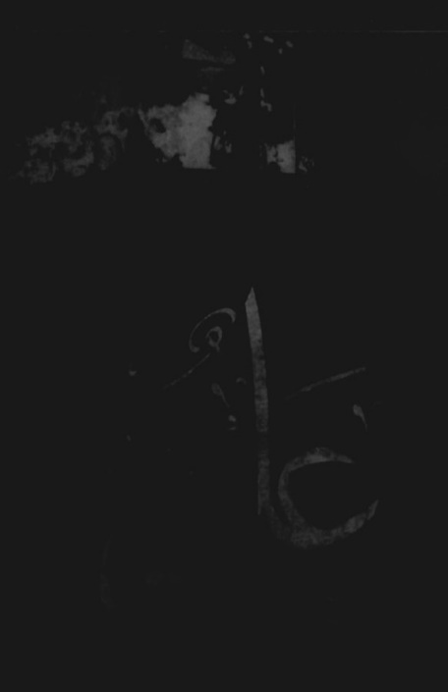 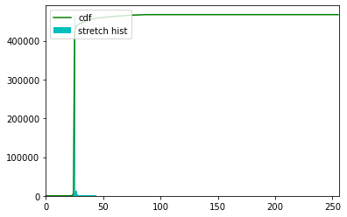

Stretched:

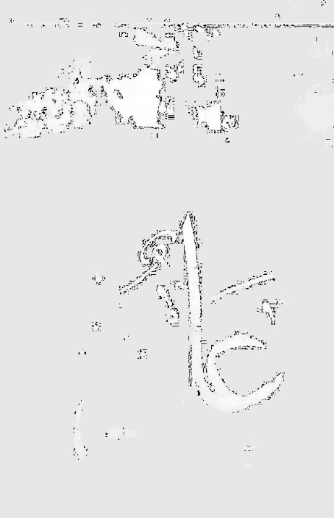 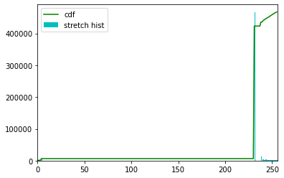

Equalized:

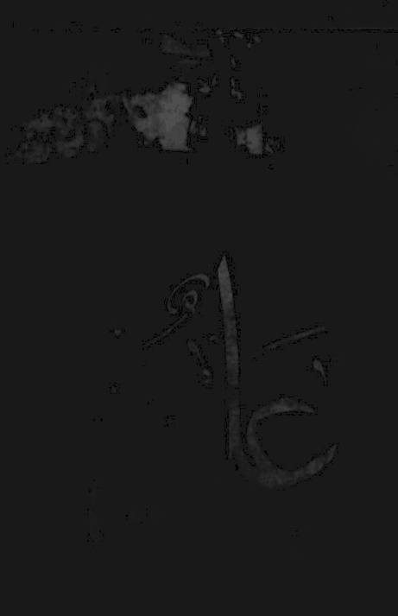 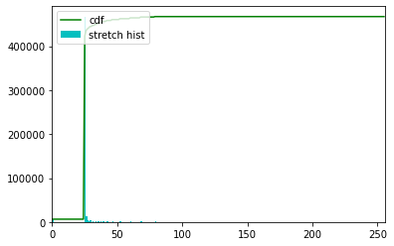

**Q8**

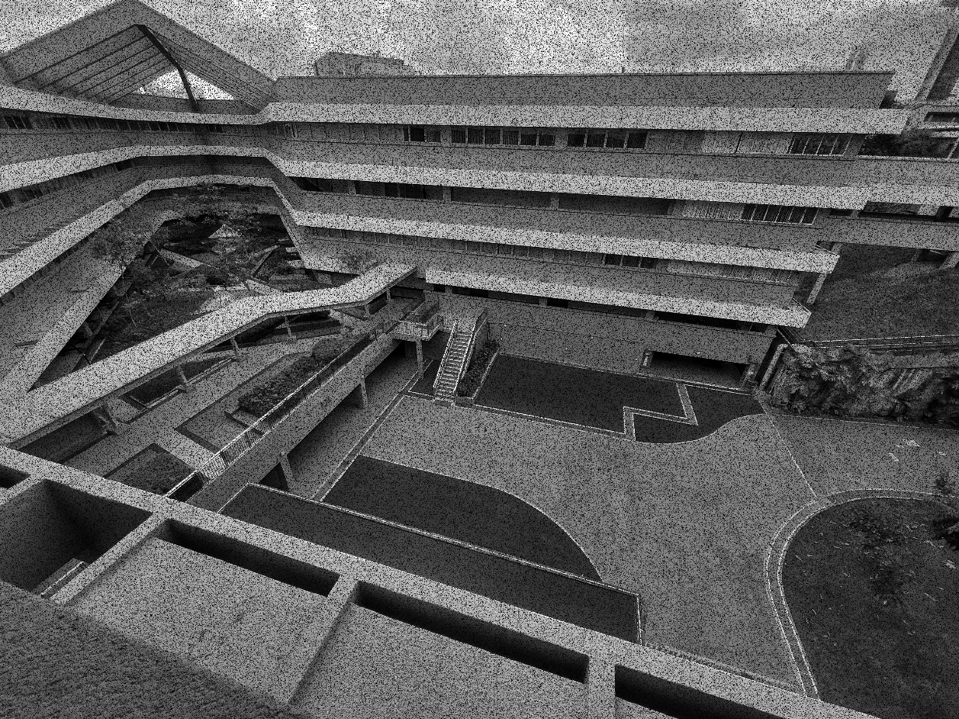

3x3 median filter:

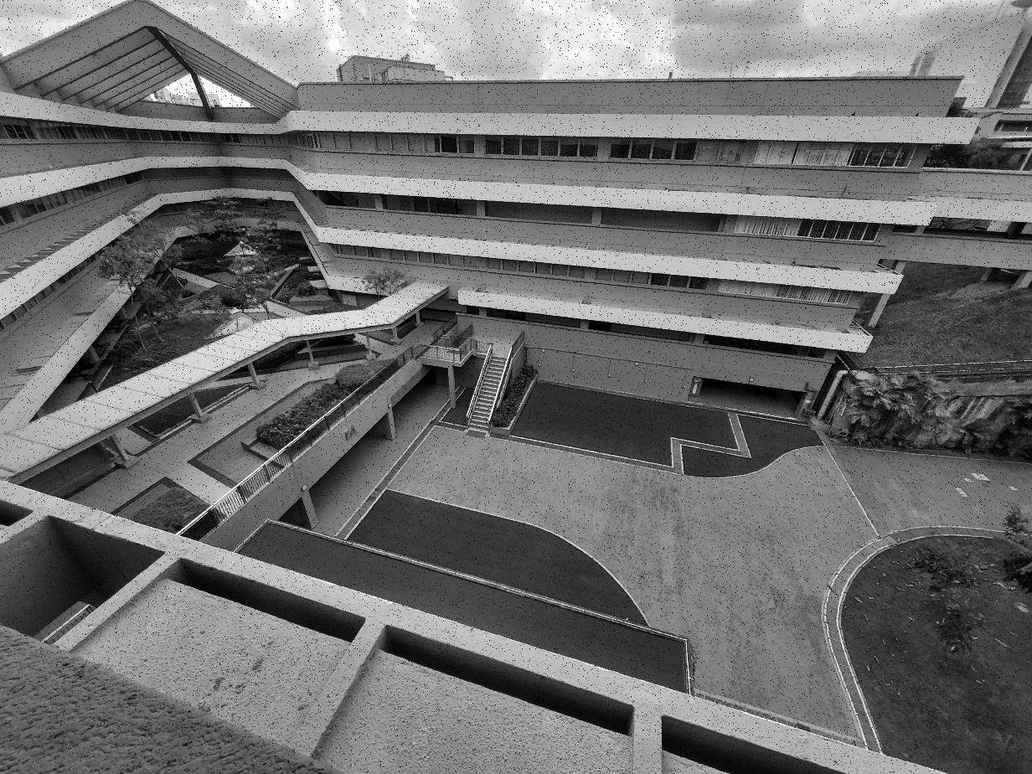

5x5 median filter:

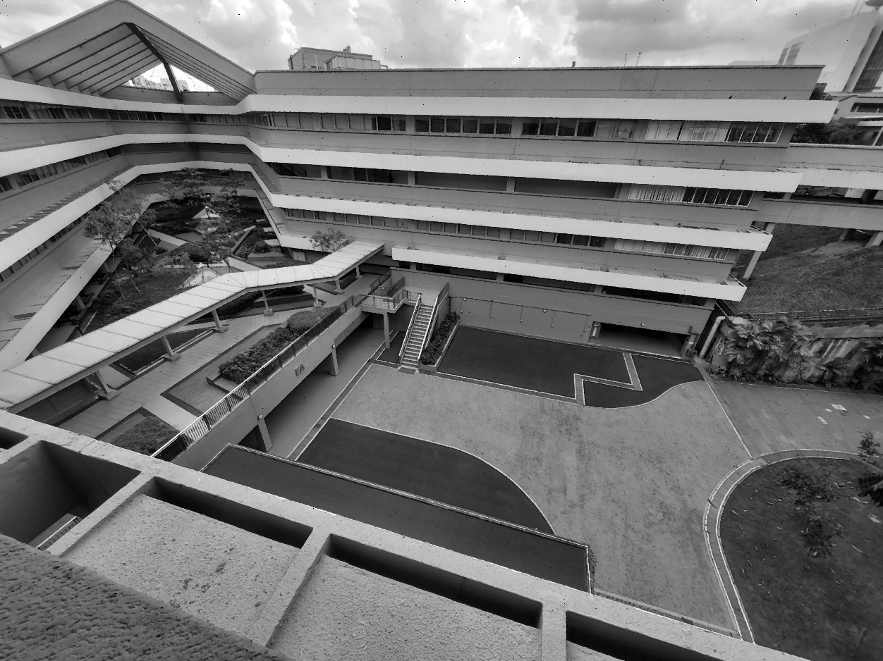

The larger the median filter, the more noise is reduced.

The noise coefficient is quite high at 20%. Hence, for a small 3x3 filter, there is a chance that in the area of effect, there might be a lot of noise, resulting in the median being the black noise pixels. Hence, in a 3x3 median filter, there is still some noise in the image.

In a larger filter, there is less of a chance that the median is the black noise pixels. Hence, there is more noise reduction.

Entropy of original image: 7.757252236684103

Entropy of noisy image: 6.923000851474356

The entropy seems to indicate that the noisy image is less random, and hence has more information, than the original image. This is likely due to the fact that the image is quite dark. Hence, assigning more pixels to dot noise pushes the histogram upwards, making it seem less random.

**Q9**

The average slightly smooths out the noise. However, since an average filter also considers the value of the noise, the noise is not well reduced.

(In the order of nc10, nc20, gauss std 10, gauss std20)

Car 1 hl1 power: 18848.971406684028

Car 1 hl2 power: 18535.054529079862

Car 2 hl1 power: 15879.539415364585

Car 2 hl2 power: 15381.133000000002

Car 3 hl1 power: 23332.673210069446

Car 3 hl2 power: 23152.050052517363

Car 4 hl1 power: 22527.753428819444

Car 4 hl2 power: 22289.177457899306Cat 1 hl1 power: 64689.633712768555

Cat 1 hl1 power: 10492.607864379883

Cat 1 hl2 power: 10195.119979858398

Cat 2 hl1 power: 8813.080749511719

Cat 2 hl2 power: 8433.35319519043

Cat 3 hl1 power: 12111.720642089844

Cat 3 hl2 power: 11892.272811889648

Cat 4 hl1 power: 12341.172622680664

Cat 4 hl2 power: 12065.997085571289

The power of the hl2 filter is less than that of the hl1 filter. This might be because the hl2 filter considers a larger area, hence bringing the pixels down to gray more. This can squash the histogram, decreasing the power.

(Using the cat gaussian std 10 to illustrate)

3x3 filter:

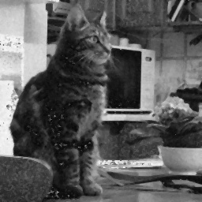

5x5 filter:

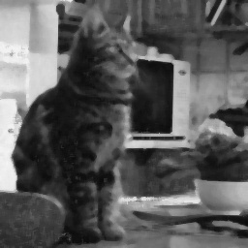

The 3x3 filter is sharper but noisier. The 5x5 filter removes most of the noise but loses some of the edges.

However, this median filter ignores outliers and is good for removing noise as compared to the average filter which also considers the value of outliers.

**Q10**

Like a Laplacian filter, this filter can exaggerate edges. However, unlike a Laplacian filter, areas of similar value are lightly highlighted due to the increase in the middle pixel value.

**Q11**

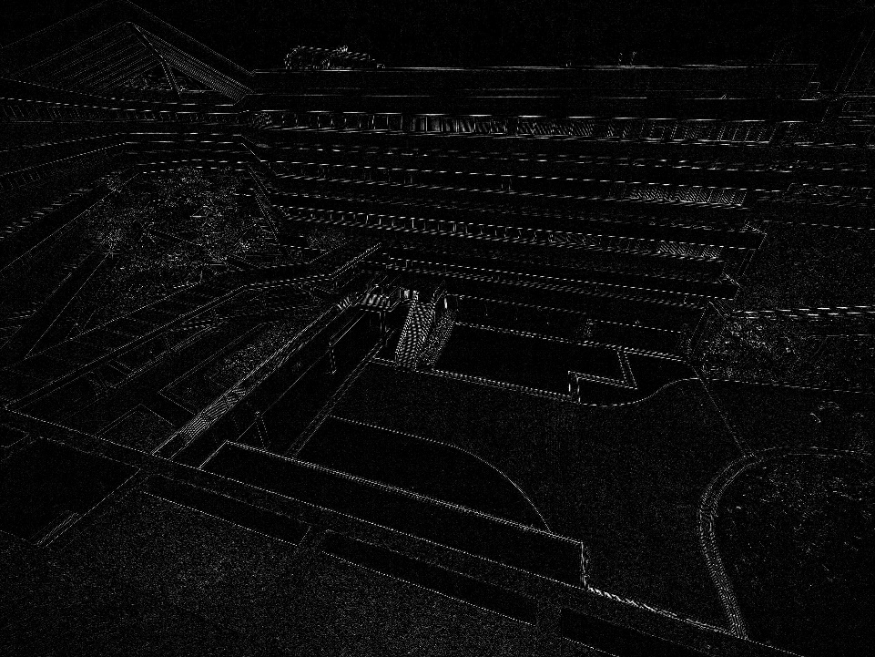

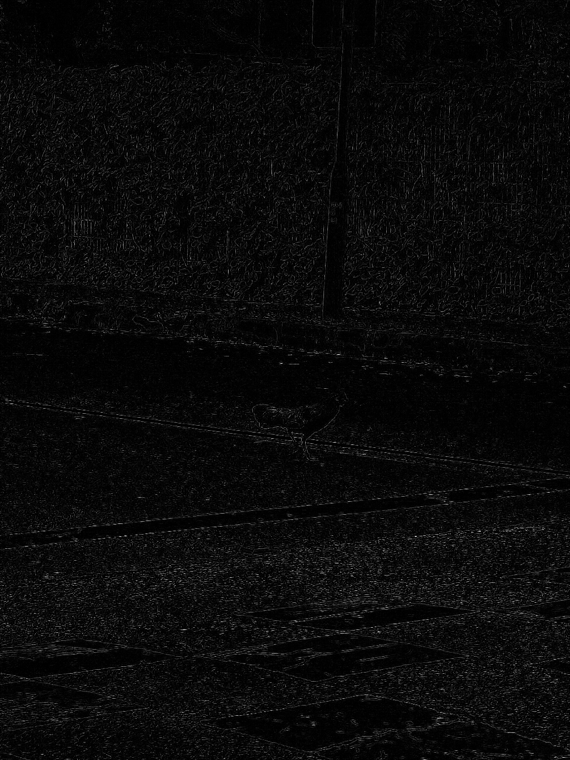

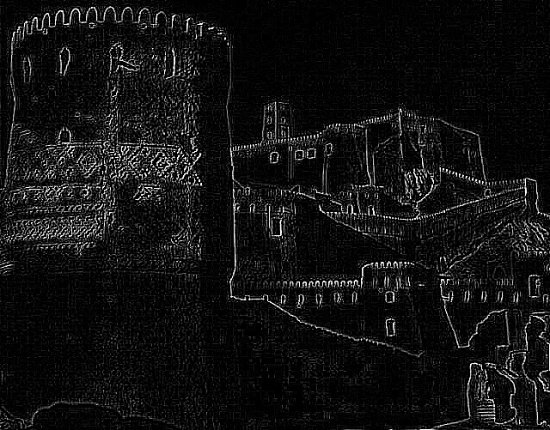

**Q12**